Someone Special Keepsakes
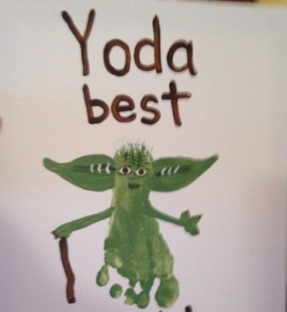
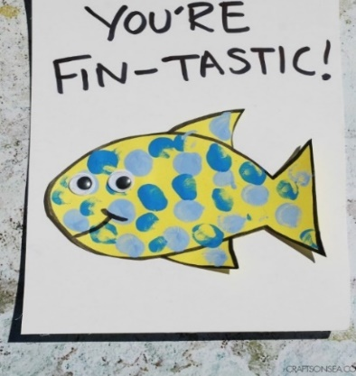

Hello everyone,

Father’s Day is will be here soon - 21st June. I thought these little ‘Someone Special’ keepsakes are cute and a little bit of fun. You can make them for anyone who is special to you - Dad, Grandpas, Grannies, friends etc.
There are 2 examples for you to choose from or you can do both. I hope you guys have great fun doing the activity – feel free to post your finished results on your online group.

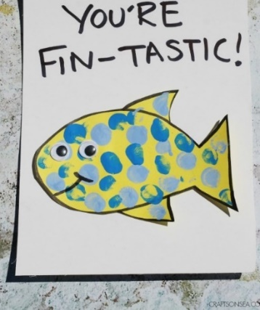
Example (1)
What you need:

- Felt pens, markers, crayons, or child safe paint
- White card
- Coloured card
- Glue stick or PVA-type glue
- Googly eyes / white scrap paper
- Scissors for adults to use

Instruction:

- Start by drawing a fish shape on to some coloured/white card. I found it was much easier to draw a normal fish shape and then add the fins afterwards.
- Cut out your fish shape
- Next decorate your fish anyway you like e.g. the children can finger paint
- Make some eyes for your fish. I’ve glued on googly eyes, but you cut out white circles from scrap paper and draw a black dot onto them to make the eyes instead
- On your white card write, ‘you’re fin-tastic’ and then stick your fish underneath

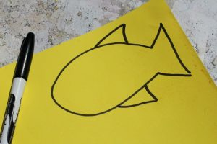

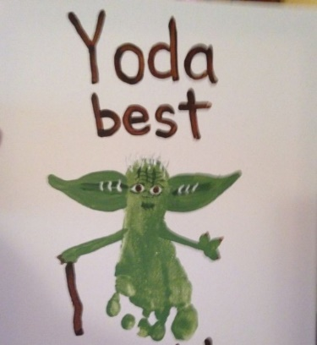
Example (2)
What you need:

- Felt pens, markers, crayons, or child safe paint
- Paint brush or sponge
- White card or white scrap paper
- Glue stick or PVA-type glue
- Googly eyes / white scrap paper
- Scissors for adults to use

Instructions:
- Get your workspace ready with a white card or paper and the kid’s paint
- Paint your child’s foot with green paint to make Yoda! Now press your child’s foot in the centre of paper to get the footprint
- Use some more green paint to make the ears and a marker or felt pen to draw little walking stick
- Once dried - for the eyes - you can draw them in with a marker on white paper or card, then stick them on
- Now it’s time to write ‘Yoda Best’

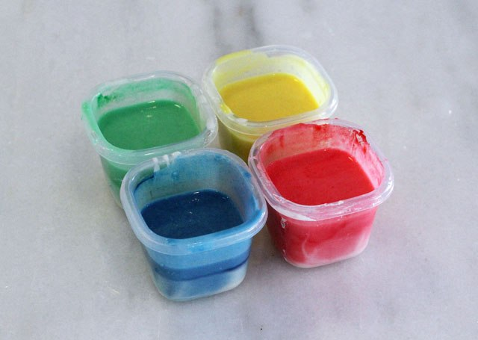
Baby safe paint recipe
What you need:

- 1 cup of warm water
- Food 1 cup of plain white flour
- Colouring as required
- Whisk

Instructions:

- Mix the flour and water together, using the whisk until smooth and lump-free
- Divide the mixture into four bowls, cups or containers.
- Add the food colouring to each container and mix (around 3 drops)

Learning Opportunities:
- Sensory texture exploration
- Creativity and Imaginative Play
- Fine Motor Skills
- Concentration
- Language development
- Boost Self Esteem
- Problem solving – overcoming challenges
- Colour and shape recognition
- role-play social/emotional development
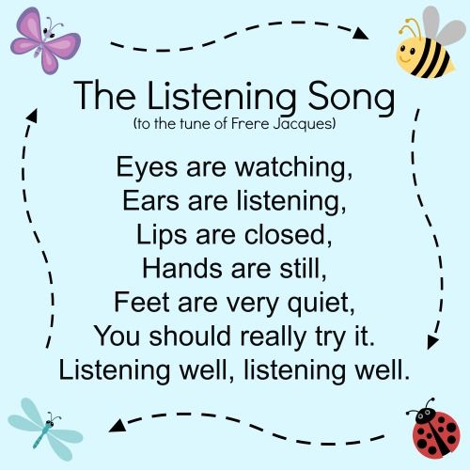

Story time:
Start with the Listen song:
followed by Twinkle Twinkle Star- as these songs help settle the children before the story

Click on the link below: It’s a great interactive story

https://www.youtube.com/watch?v=1u_VTr3o24w

Click on the link below: I just love this little song

https://www.youtube.com/watch?v=ug1pI-Ephns

I hope you have lots of fun doing this week’s activity.

Love Annie Walker x

