Activity – Cloud Dough (non-toxic and taste-safe)
What you need:
- Storage container, plastic container, tub or similar.
- Large bowl.
- Wooden spoon.
- 4 cups of flour.
- ½ cup vegetable oil.
- To make a larger amount double your ingredients.
- Fun sensory item - scoops, small plastic cups, plastic molds, silicon molds and spoons. For older children you can pop in small farm animals ‘small dinosaur’s toys.
- Air-tight container.
Instructions:
STEP 1: Put all ingredient into large bowl and mix them together.
STEP 2: Stir vegetable oil and flour together until it’s soft and silky - It took me a good 10 mins.
STEP 3: Using your fingers, squeeze and press the cloud dough to blend the oil throughout the flour.
STEP 4: Transfer your cloud dough into your container and add scoops, spoons, cups, toys and so on.

Cloud dough is so lovely to the touch, the children of all ages will simply love running their hand through it, squeezing and shaping the dough and watching it crumble when they release it back into the box. I’ll bet you mums and dads won’t be able to keep your hands off it either.
When finished playing with cloud dough store in an air-tight container for another day.

Learning Opportunities:
- Sensory texture exploration
- Creativity and Imaginative Play
- Fine Motor Skills
- Concentration
- Language development

Story time:
Why is it important to read to your little ones?
Reading books aloud to children stimulates their imagination and expands their understanding of the world. It helps them develop language and listening skills and prepares them to understand the written word.

Start with the listening song.
Followed by Twinkle Twinkle Little Star – the little ones enjoy these songs and its helps to settle them before story.

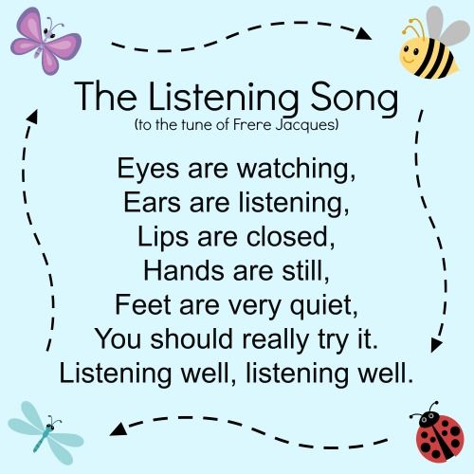

Click on the link below. It’s a great interactive story from Booktrust.

https://www.booktrust.org.uk/books-and-reading/have-some-fun/storybooks-and-games/everybunny-dance/

Once story ends, I thought it be nice to sing Sleeping Bunnies https://www.youtube.com/watch?v=BRjsyzbvqsc and you mums and dads old favourite https://www.youtube.com/watch?v=XqZsoesa55w

Love Annie Walker x

